**CEDS Website and Alignment ‘How To’ Guide**

**How to Access CEDS**

<http://ceds.ed.gov/>

**How to Get CEDS Access – New Users**

1. Click on the ‘Create an Account’ link from the homepage.

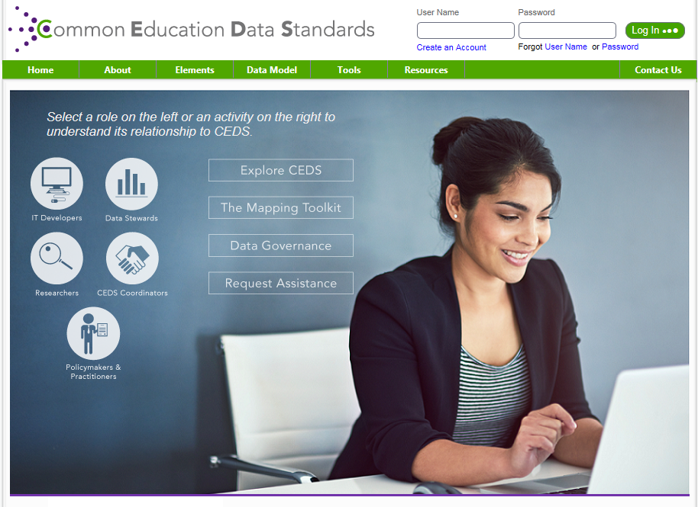

1. Use your SOM email address ‘Email Address’ and SOM ID for ‘User Name’. Fill in all required fields and click on ‘Create Account’.

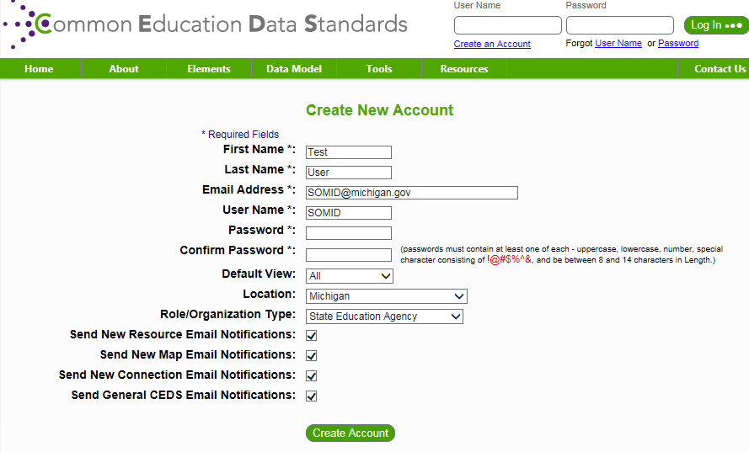

1. New Users will receive an email with a link. Click on the link and you should receive the following message from the CEDS website:

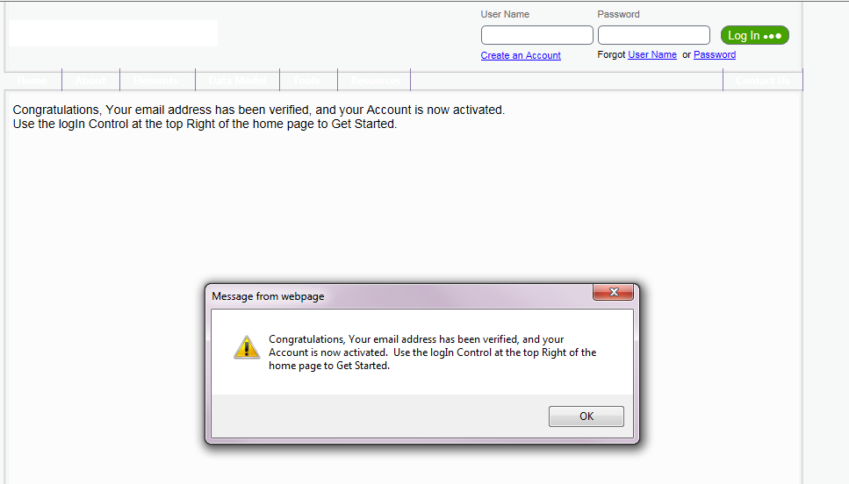

1. Sign into CEDS by typing your User Name and then click on ‘Forgot Password’ link:

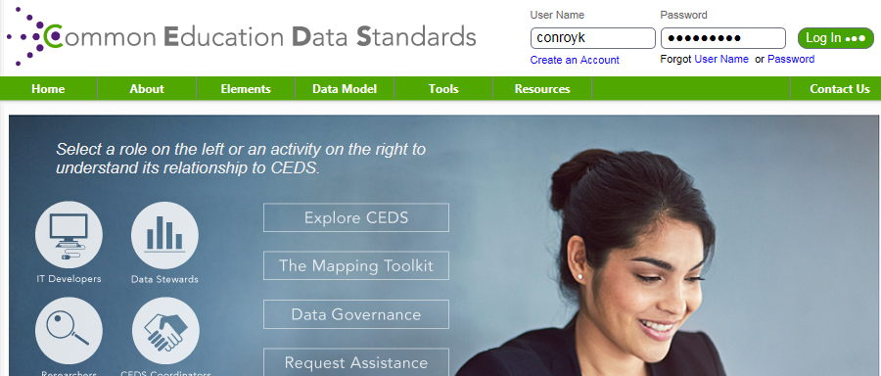

1. You will be asked to enter your email address. Then you will receive an email with a link to reset your password. Follow the password setup requirements.
2. At this point you can sign into CEDS with your username and password.
3. If for some reason your email gets deleted or you have problems with setup, we will need to work with the CEDS Align contact to complete the setup.

**How to Get CEDS Access – Existing Users**

1. The CEDS project coordinator will send an existing user their existing ‘User Name’, which is usually your SOM ID. Enter your ‘User Name’ in the top right corner of the CEDS home screen.  If you have forgotten your password, click the Forgot ‘Password’ link and CEDS will allow you to change your password.

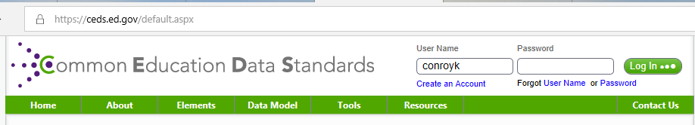

**How to Find CEDS Align Training**

1. In CEDS:
   1. From green menu bar: Tools/Align and select the ‘Access Align Tutorials’ button
   2. Total of 9 short videos (less than 1 hour 20 minutes).
      * Getting Started (3 mins)
      * What’s New in V7 (9 mins)
      * Creating Map (5 mins)
      * Map Administration (7 mins)
      * Uploading Dictionary (10 mins)
      * Aligning Elements to CEDS – Align Module 4 Part 1 (5.4 mins) and Part 2 (10 mins)
      * Using Map (7 mins)
      * Creating Reports (19 mins)
2. The CEDS Alignment webinar given by The CEDS Align contact (Nancy Copa) from CEDS on 5/5/15 was recorded and is available for viewing at the following link. Although some of the information is outdated, the video still contains some very good training points:

<https://edinfoevents.webex.com/edinfoevents/lsr.php?RCID=afee7245e771386c560338dfdedb1b06>

1. CEPI has created some of our own internal ‘Lessons Learned’ documents, based on our experiences with Align mapping, for example ‘CEDS Align MSLDS Mapping Process_v3’ found in ‘S:\CEPI Data\CEDS Folders\CEDS Reference\CEDS v7.1 Training OAR’ folder.

**Where to Find CEDS V7.1 Data Element Dictionary?**

**There are lots of ways to view the CEDS data dictionary online, here are some of the options:**

1. Choose Elements/Download/Access Version 7. On the CEDS Element Downloads screen, choose ‘Complete Version 7.1 file’, as this will contain Domain/Entity/Category hierarchy.



1. ‘Complete Version 7.1 file’ can be handy to use as you can filter on the data element domain/entity/category and look all data elements to see what other CEDS data elements might map to CEPI data elements.

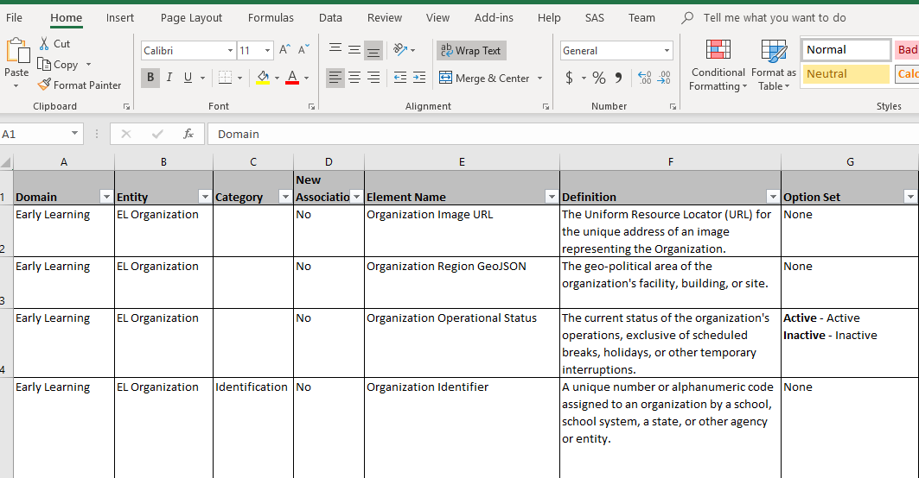

1. Elements/View Elements– CEDS Elements Version 7.1 screen
   1. Choose ‘All’ for ‘Filter by First Letter’ and a complete element list is displayed in alphabetic order.

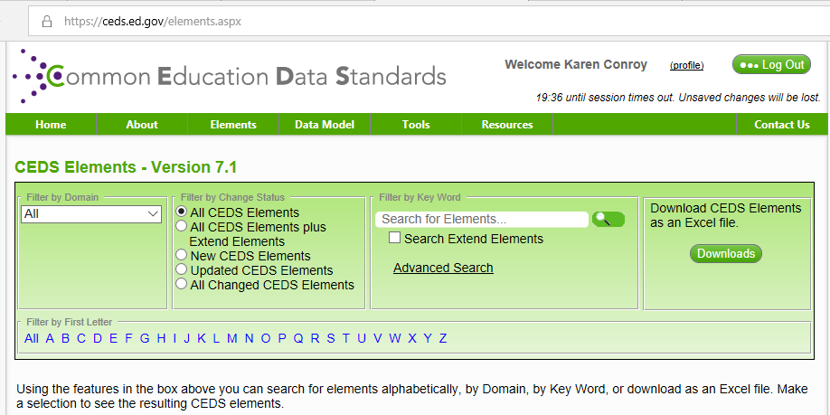

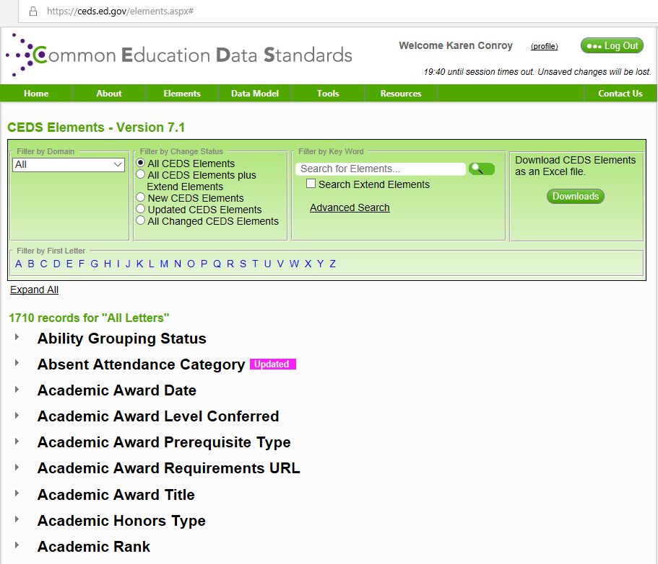

* 1. Search by keyword and all related elements are displayed.

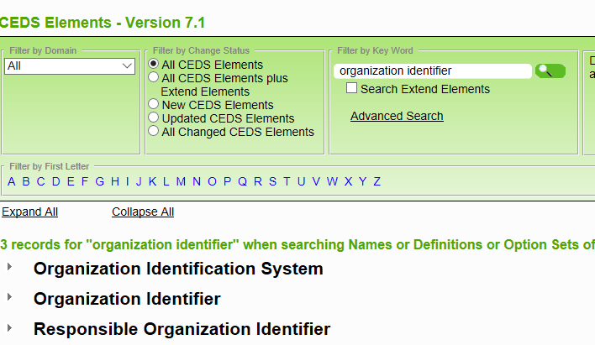

* 1. You can also select the Domain you want to filter on in the ‘Filter by Domain’ box.

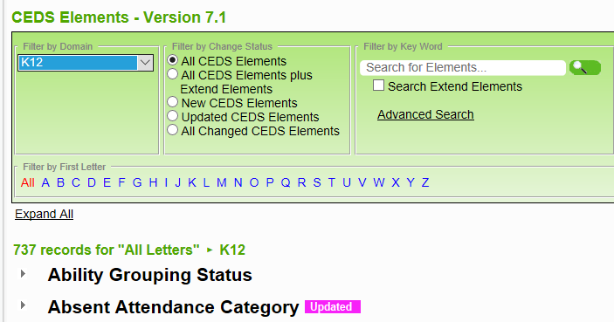

1. Elements/View Domain Entity Schema – CEDS Elements Version 7.1
   1. This is a good way to view CEDS data that is grouped by domain



**How to Create a CEDS Align Map**

1. Align Module 1 walks you through the steps. You must create a map prior to being able to upload to the map.
2. Once a map has been created, you may want to add other users so that they can view and/or make updates to the map. Steps for this are found in Align Module 2.

**How to Upload a Data Dictionary to a CEDS Align Map**

1. Align Module 3 walks you through the steps. You must create a map prior to being able to upload to the map.
2. The most current upload template can downloaded from the CEDS tool; a current copy ‘dat-xls-template-v7_1-Upload (1)’ can be found in the ‘S:\CEPI Data\CEDS Folders\CEDS Reference\CEDS v7.1 Training OAR’ folder.
3. On the Metadata tab, fill out the following fields:

|  |
| --- |
| **System Name** |
| **Database Name** |
| **Table Name** |
| **Element/Field Name** |
| **Element Definition** |
| **Data Type** |
| **Length** |

* Option sets can be added after you have uploaded the base data dictionary information to your map via the Align tool.

**How to Align a New Michigan Map**

1. Align Module 4 Part 1 and 2 walk you through the basic steps for aligning Michigan data elements to the CEDS data dictionary.
2. After you sign in with CEDS ID and password, go to Tools/Align/Manage Maps and select the new map. Follow the steps from the Align tutorial to map each data element. You can add option set choices here as well.

**How to Look Up Existing Michigan Maps That Have Been Aligned**

1. After you sign in with CEDS ID and password, go to Tools/Align/Manage Maps

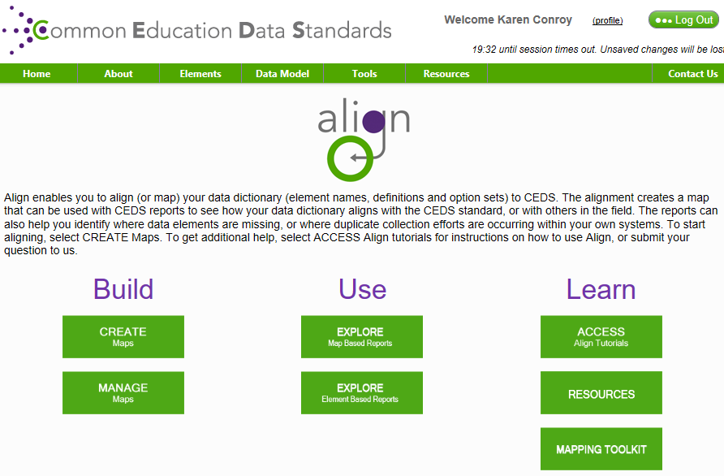

1. Select the Michigan map you want to view:

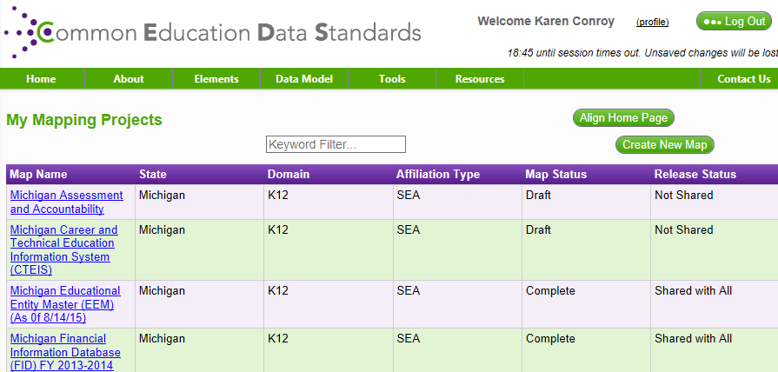

1. From the Manage Map screen, choose Data Elements/Align Elements and this will display the list of data elements within the map

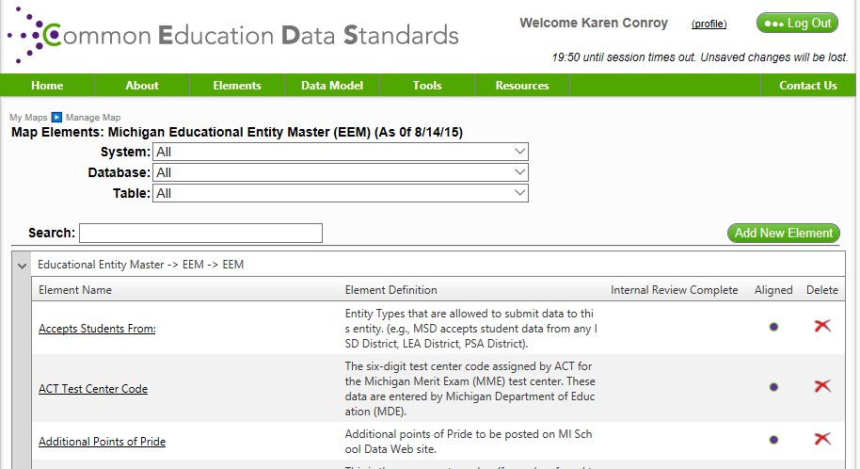

1. ‘Entity Type’ was selected which brings you to the ‘Modify Element Map’ screen where you can see how the element was mapped and also make updates if needed

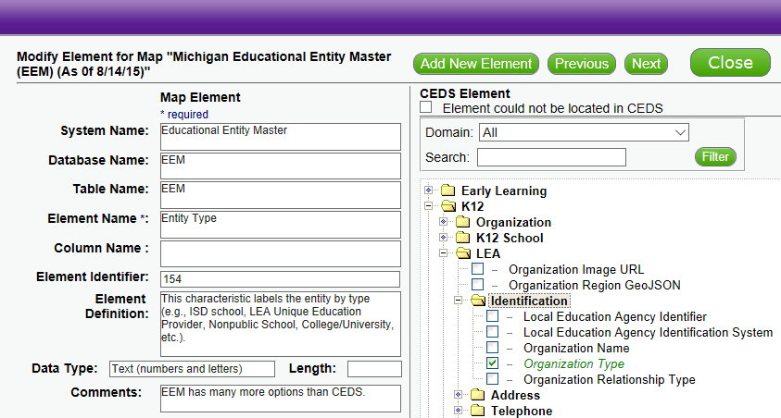

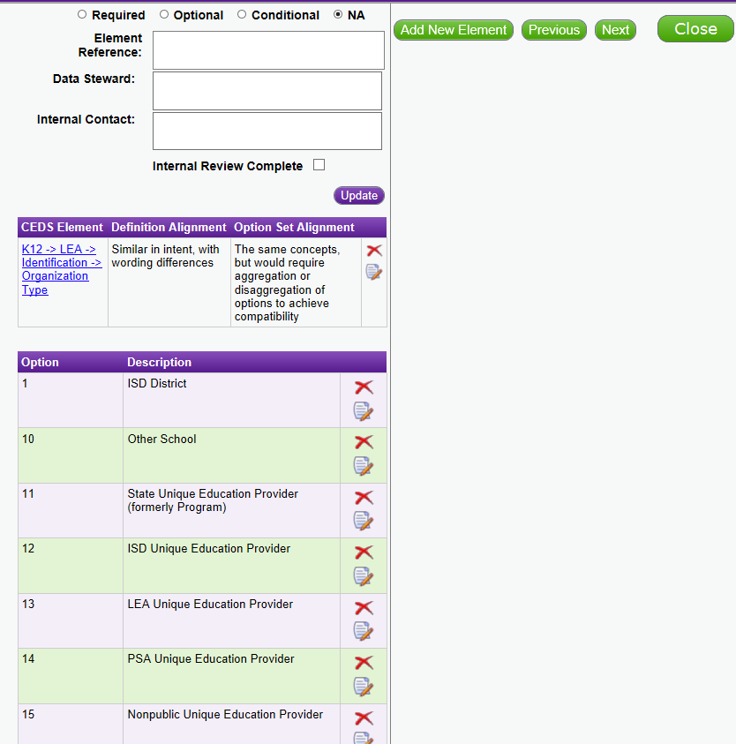

**Definition Alignment Choices (See the Quick Tips for more detail and examples.)**

|  |  |  |
| --- | --- | --- |
| ***Definition Response ID*** | ***The definitions of alignment are:*** | ***Use when:*** |
| 1 | Identical in wording | The user should select this option if the definition is exactly the same as that of the CEDS element. |
| 2 | Identical in intent, with wording differences | States can use this option if the definitions have the same underlying purpose but have differences in wording. |
| 3 | Identical in intent when aggregated or disaggregated | Identical in intent when aggregated or disaggregated. In some cases the user’s data source may include elements that can potentially be mapped to a CEDS element but need to be either broken up or combined to match it. |
| 4 | Similar in intent, with wording differences* | States may select this option if the definitions have closely related underlying purposes (but not exact), and the wording of the definitions is similar. In this case, a user may include elements that are specific to a given data source that do not have an exact match in CEDS, but can be shown to be similar to a particular CEDS element. |
| 5 | Related only at a concept level, with differences in the intent* | Related only at a concept level, with differences in the intent. A user may select this if the underlying purposes of a data source element and a chosen CEDS element can be related conceptually, but the actual usage of the element by an education entity would not be the same as that of the CEDS element. |
| 6 | No element definition available in the stakeholder data dictionary | A user should select this when the data source does not provide a definition for a given element. |

**Option Set Alignment Choices (See the Quick Tips for more detail and examples.)**

|  |  |  |
| --- | --- | --- |
| ***Option Set Response ID*** | ***The option sets have:*** | ***Use When:*** |
| 1 | Exactly the same options and definitions | The user should select this option if the codes are exactly the same as those of the CEDS element. |
| 2 | The same number of options, but would require transformation on value to align with CEDS code set | In some cases, the two elements have the same codes generally, but provide the options in a slightly different way. |
| 3 | The same concepts, but would require aggregation or disaggregation of options to achieve compatibility | This occurs when the user’s element has more or fewer codes than the CEDS element and the user needs to combine them or separate them to align them with the CEDS element‘s codes. |
| 4 | Very few or no options that relate; e.g. one has more than the other and cannot be aggregated/disaggregated to make them the same | In some circumstances, the state or other education entity views the element differently enough that its codes are entirely different from those of the aligned CEDS element. Any sort of combination or separation of the codes would not result in alignment with the codes in the CEDS element. |
| 5 | Not Applicable (Element does not contain a code set) | The user should choose this option when the state element does not contain an option set. |
| 6 | |  |  | | --- | --- | |  | No option set definition available in the stakeholder data dictionary and/or for  the CEDS element. | | Use this when no option set definition is available for the data element for the state and/or CEDS.  Select this either when: 1) Use this when CEDS has an option set but the state has not provided the option set to CEDS 2) State data dictionary contains option set codes (but no definitions), but CEDS does not contain option set codes/definitions. |

**How to Change a Data Element in CEDS**

1. **From the Modify Element Map screen, display the REP ‘New Teacher Professional Development’ element, which has a definition alignment ‘Similar in intent, with wording differences’,**

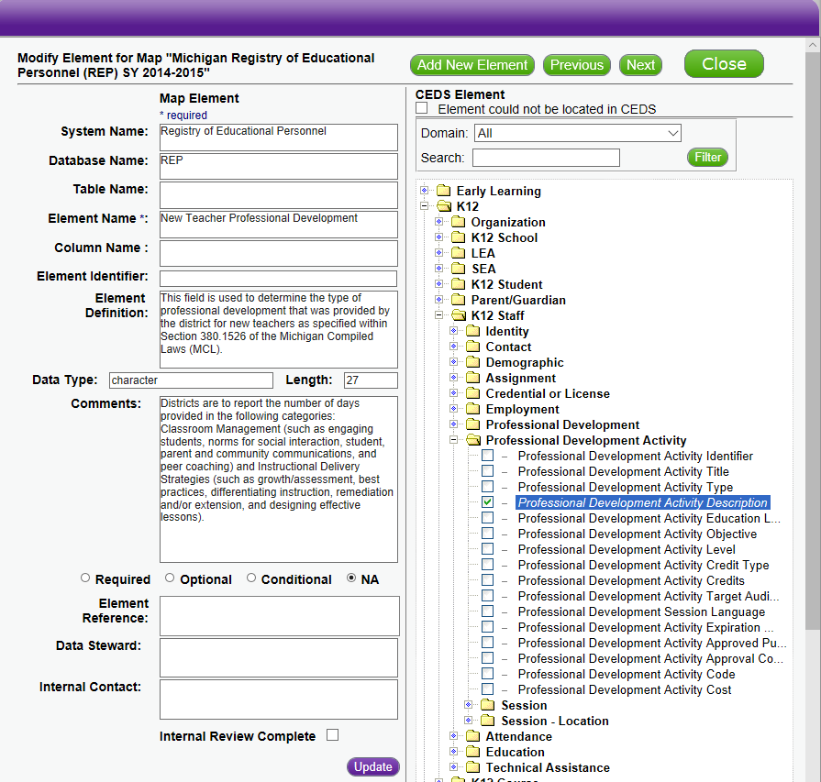

1. **Click on the CEDS Element link as shown below:**

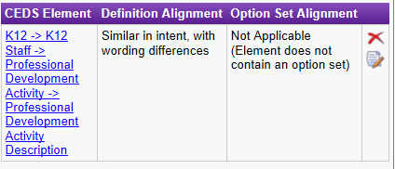

1. **The following Element Details screen is displayed. Note that the CEDS Element ID is the Global ID found in the CEDS ODS.**

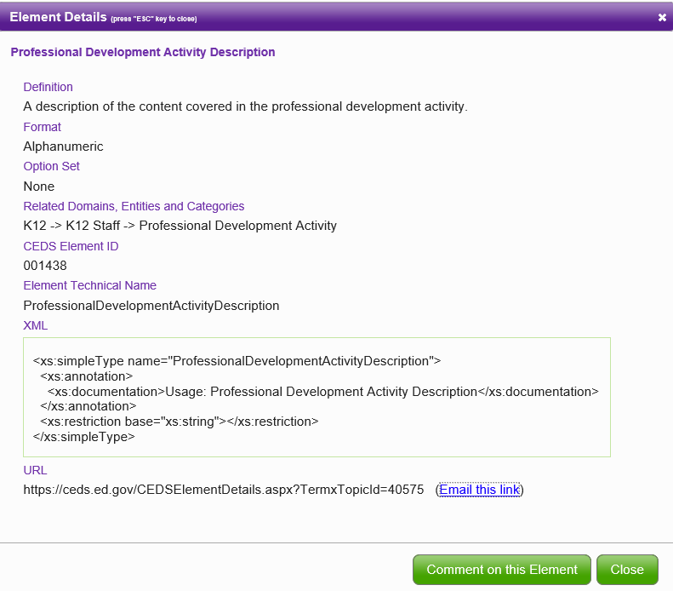

1. **Let’s say we think the CEDS definition is too broad for how we use this data element in Michigan and want to change the definition Alignment. Click on the edit icon as shown below:**



1. **This will bring up the Alignment screen:**

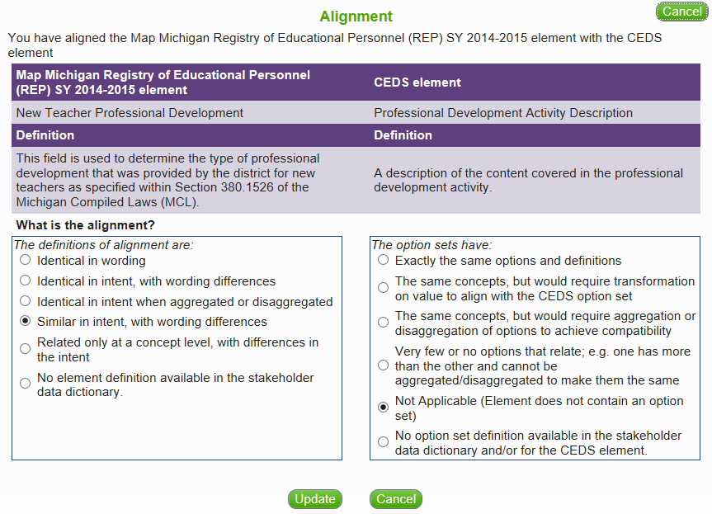

1. **The alignment was changed to ‘Related only at a concept level, with differences in intent’ followed by clicking the Update button.**

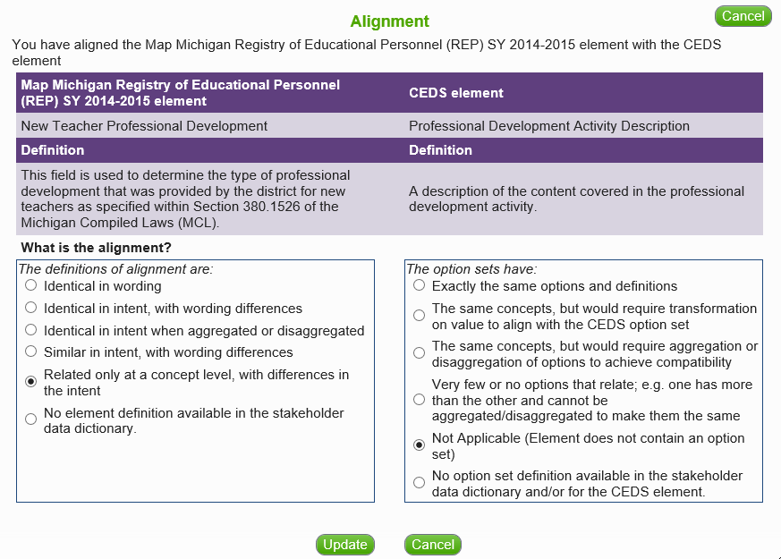

1. **Now the CEDS Alignment is displayed as:**

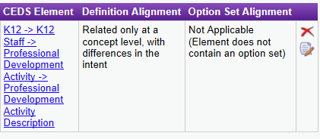

1. You can **Update** any of the Map Element (State) fields: System name, database name, table name, element name, column name, element identifier, element definition, data type, length, comments, required/optional/conditional/NA, element reference, data steward, internal contact, internal review complete.

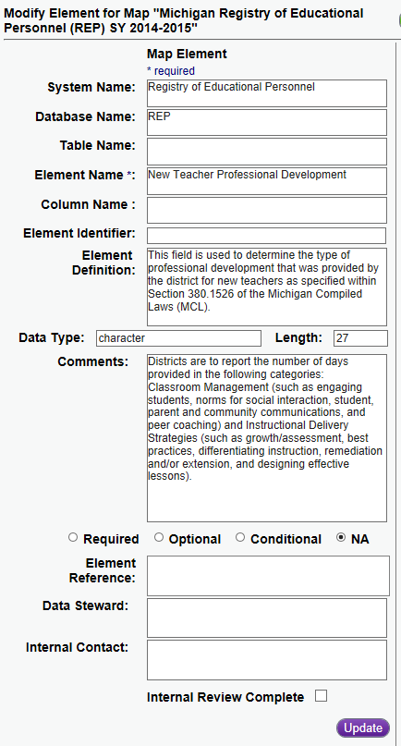

1. You can **Add** the Michigan option set choices here as well. Here is Racial Ethnicity from REP:

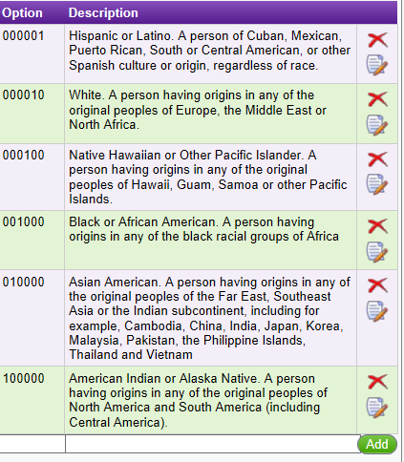

If there are 15 or fewer option set choices, add the option set choices within the Align tool. If there are greater than 15 choices, one option is to place the URL to a document that contains the option set in the **Comments** area in the Align tool. Another option is to upload the data element with the option set choices using the CEDS upload template.

**How to Add a Data Element in CEDS**

1. **From the Map Elements screen, choose ‘Add New Element’. Here we add a test data element for the STARR map:**

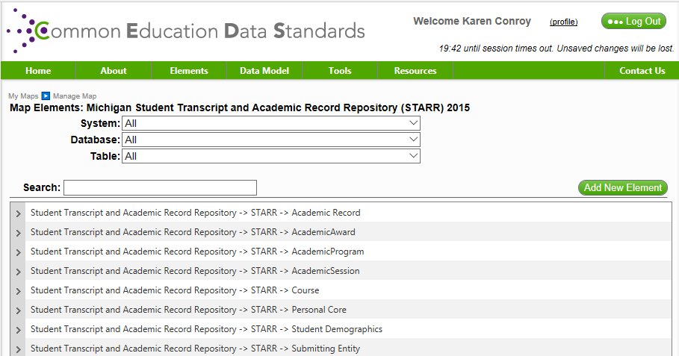

1. **Here you will need to enter the System Name, Table Name (optional), Element Name, Element Definition, Data Type, Length, Comments, Required/Optional/Conditional /NA (optional), Element Reference (optional), Data Steward (optional), Internal Contact (optional). Click on Next button to add the record.**

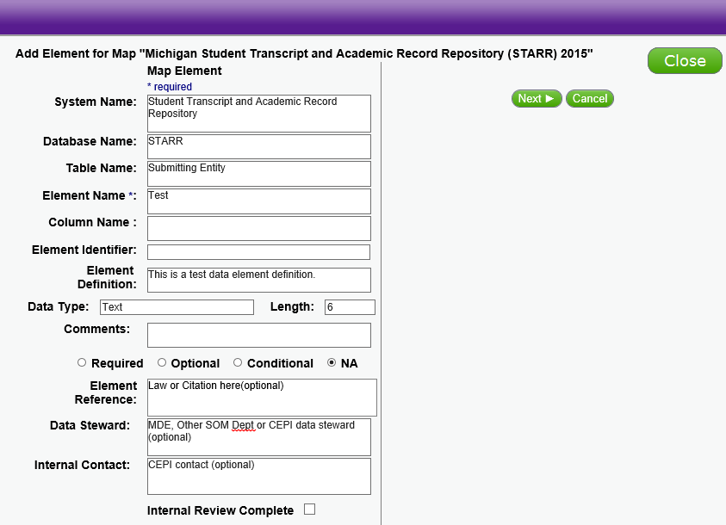

1. **This will result in the following screen being displayed, where you can finish the data element, definition and option set alignment:**

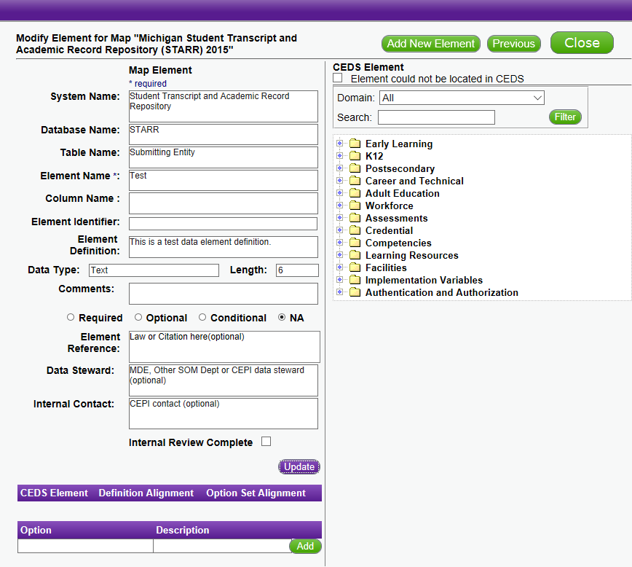

1. **After you ‘Close’ the previous window, you will be returned to the Manage Map screen where you can see the data element you just added.**

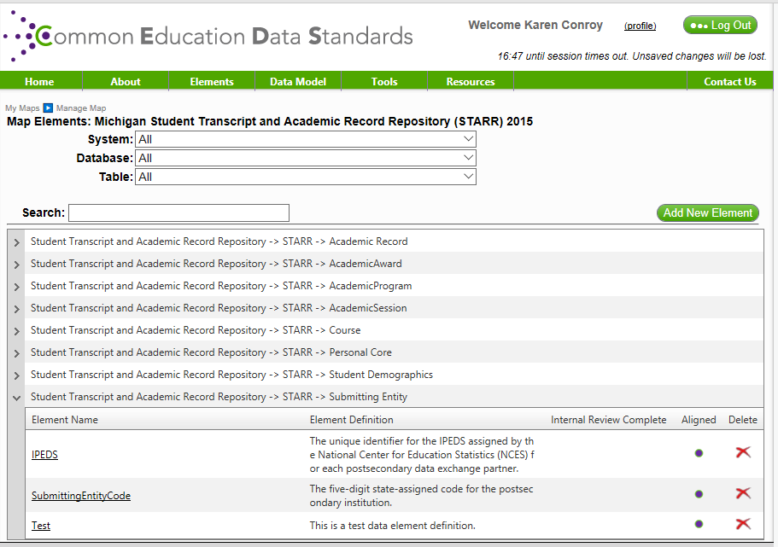

**How to Delete a Data Element in CEDS**

1. **From the Map Elements screen, expand the category to find the element you want to delete**

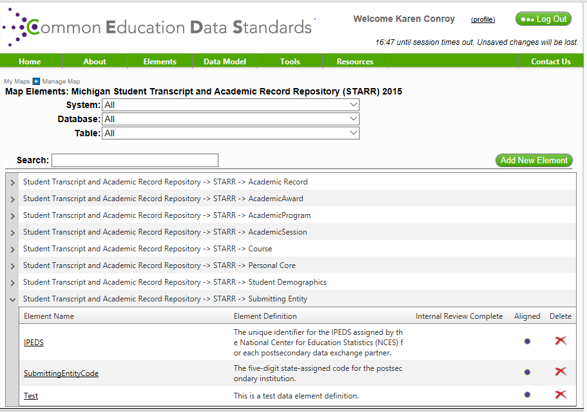

1. **Simply click on ‘Delete’ to remove the record, then click OK at the prompt**

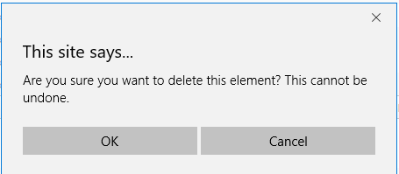

1. **The element has been removed**

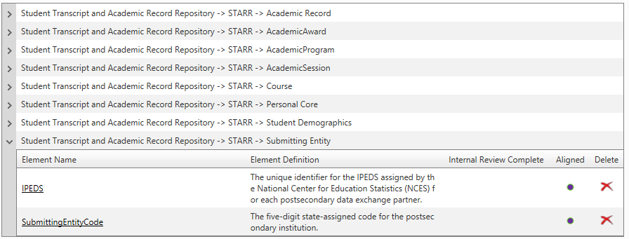

**How To Add Another User to Your Map**

**From the Manage Map screen, go to Map Administration/Manage User Access.**

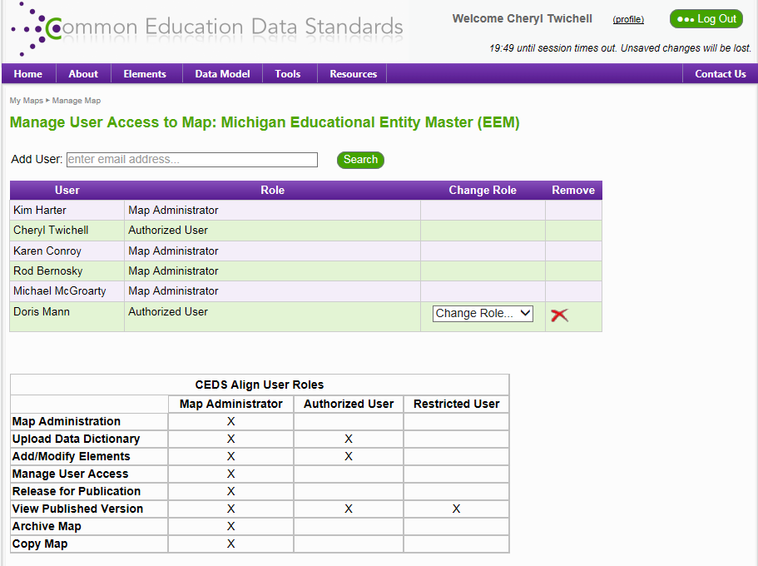

**Here is the screen shot after entering an email address and clicking 'Search' button:**

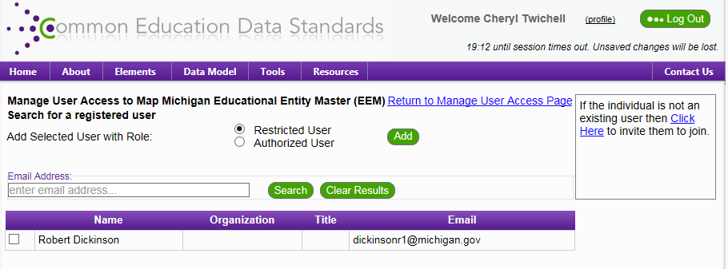

**Here is the screen shot after clicking the 'Authorized User' radio button, the check box by his name, and the clicking the 'Add' button:**



